Statistical Reasoning

Bivariate Data

Scatterplots and Regression Name: Date: Class:

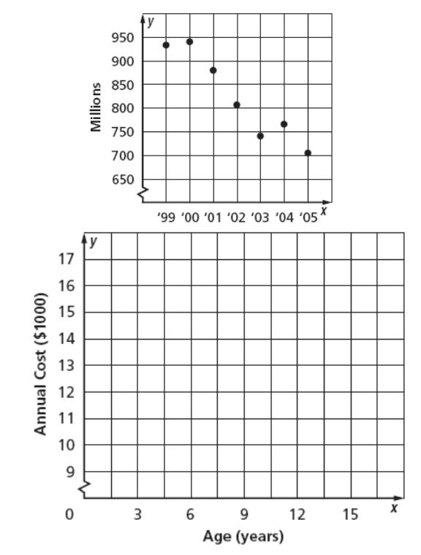

**Scatter Plots and Lines of Best Fit Worksheet**

1. **MUSIC** The scatter plot shows the number of CDs (in millions) thatwere sold from 1999 to 2005. If the trend continued, about how many CDs were sold in 2006?



1. **FAMILY** The table below shows the predicted annual cost fora middle income family to raise a child from birth until adulthood. Draw a scatter plot and describe what relationship exists within the data.

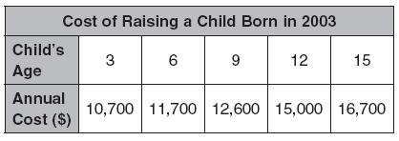

1. Make a scatter plot of the data in the table. Draw a line of best fit. What is the equation of the line of best fit?

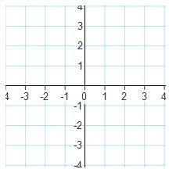

|  |  |  |  |  |  |  |  |  |  |  |
| --- | --- | --- | --- | --- | --- | --- | --- | --- | --- | --- |
| X | -2 | -2 | -1 | 0 | 1 | 1 | 1 | 2 | 2 | 3 |
|  | 2 | 3 | 2 | 1 | 0 | 1 | -1 | -1 | -2 | -2 |
| Y |

1. **EDUCATION** The table at the right givesthe number of hours spent studying for a science exam and the final exam grade.

|  |  |  |  |  |  |  |  |
| --- | --- | --- | --- | --- | --- | --- | --- |
| Study Hours | 3 | 2 | 5 | 1 | 0 | 4 | 3 |
| Grade | 84 | 77 | 92 | 70 | 60 | 90 | 75 |

1. Draw a scatter plot of the data and draw in the line of best fit.
2. What is the equation for the line of best fit?



1. Predict the grade for a student who studied for 6 hours.
2. Could this line go on forever? Why or why not?
3. 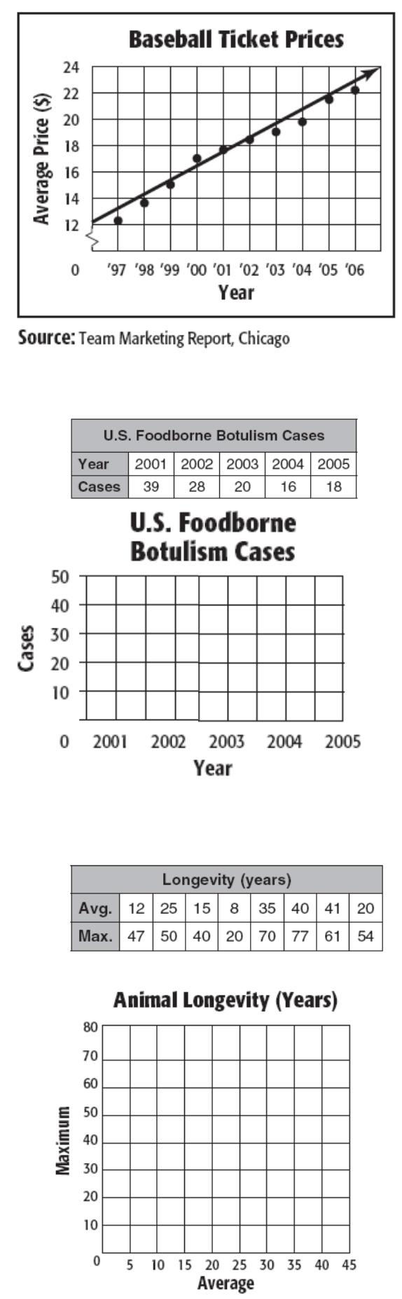**BASEBALL** The scatter plot shows the average price of a major-league baseball ticket from 1997to 2006.
   1. Use the points (2001, 17.60) and (2002, 18.75) to write the slope-intercept form of equation for the line of fit shown in the scatter plot.
   2. Use your equation to tell the price of a ticket in 2009. Is this extrapolation or interpolation?



1. **DISEASE** The table shows the number of cases of FoodborneBotulism in the United States for the years 2001 to 2005.
   1. Draw a scatter plot and identify the shape, direction, and strength.
   2. Draw a line of fit for the scatter plot, and write the slope-intercept form of an equation for the line of fit.



1. **ZOOS** The table shows the average and maximum longevity ofvarious animals in captivity.
   1. Draw a scatter plot and identify the shape, direction, and strength.
   2. Draw a line of fit for the scatter plot, and write the slope-intercept form of an equation for the line of fit.
   3. Predict the maximum longevity for an animal with an average longevity of 33 years. Is this an example of Extrapolation or Interpolation?